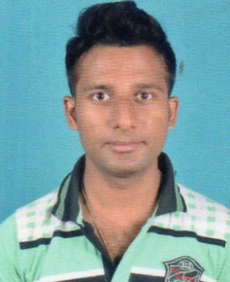
RESUME
NAME- -HEMANTA HAZARI
FATHER’S NAME--SUJIT HAZARI
D.O.B—05-12-1996
ADDRESS—
VIL: MELERA
PO: MELERA
PS: BARIKUL
DIST: BANKURA
PIN: 722162
STATE-WEST BENGAL
CONTACT NO:8016034569
E-MAIL:hazarih3@gmail.com
EDUCATION QUALIFICATION
EXAM PASSED | NAME OF THE BOARD | YEAR | MARKS
M.P | W.B.B.S.E | 2012 | 66%
H.S(SCIENCE) | W.B.C.H.S.E | 2014 | 58%
B.SC (3RD YEAR RUNNING) | VIDYASAGAR UNIVERSITY
EXTRA QUALIFICATION- 1 Year Computer Diploma in Information
Technology (IT)& one year advance diploma in Tally Application ……
HOBBIES- TRAVELLING AND NET SURFING
LANGUAGE KNOWN-BENGALI,ENGLISH,HINDI
NATIONALITY-INDIAN
RELIGION-HINDUISM
CASTE-GENERAL
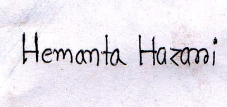
DATE-
PLACE-MELERA SIGNATURE
I HEREBY DECLARE THAT THE ABOVE MENTIONED DETAIS ARE TRUE AND CORRECT BEST OF MY KNOWLEDGE AND BELIEF…….

