Govinda Das
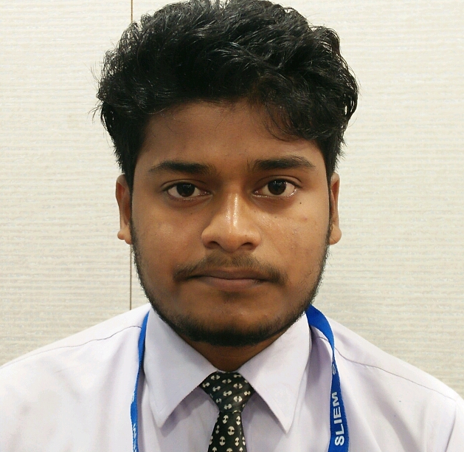
Address: Santipur, Mathura Nagar Hillside
PO. Bharalumukh, Guwahati-781009
Phone No: 9957101643
E-mail ID: dgovinda49@gmail.com

Career objective
To establish career with a leading company and achieve my goals by hardworks.
Education Qualification
- 10+2 from Sonaram Higher Secondary School, Under AHSEC Board 2014
- Passed 10th from Sonaram Higher Secondary School, Under SEBA Board 2012

Strength
- Work hard physically or Mentally in complicated situations.

Technical Qualification
- Computer Hardware & Networking (six month Certificate Course)
- Tally
- Departmental Manager, SLIEM(Three Month Certificate Course)

Language Known
- English
- Hindi
- Assamese

Extra Curricular Activities
- Transport Coordinator “AIBA world Boxing Championship 2017”
- Certified Volunteer of “FIFA Under-17 World Cup India 2017”.
- Certified Volunteer of “South Asian Games 2016”.
- Certified volunteer of NSS(National Service Scheme) 2014-17.

Personal Details
Father’s Name : Satyanarayan Das
Father’s Occupation : Contractor
Date of birth : 18/01/1996
Nationality : Indian
Marital Status : Unmarried
Gender : Male

Declaration
I hereby declared that all the above mentioned information are true to the best of my knowledge.

Date:
Place: Signature

