RESUME
syed mofidur rahamaan
NAME : SYED MOFIDUR RAHAMAN
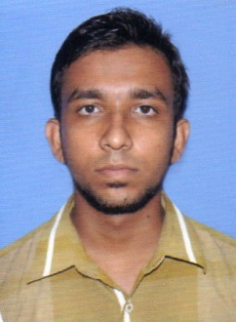
FATHER’S NAME : ATAUR RAHAMAN
DATE OF BIRTH : 18-09-1994
ADDRESS : Kashiapassimpara. Word no-19
P.O+P.S-KATWA, DIST- BURDWAN
PIN-713130, WEST BENGAL
CONTACT NO. : 8640941772
SEX : MALE
MARITAL STATUS : UNMARRIED
RELIGION : ISLAM
NATIONALITY : INDIAN
CASTE : GENERAL
EDUCATIONAL QUALIFICATION :
NAME OF EXAM | BOARD | YEAR OF PASSING | MARKS OBTAINED | PERCENTAGE
MADHYAMIK | W.B.B.S.E | 2011 | 332 | 41%5
H.S | W.B.C.H.S.E | 2013 | 161 | 31%

LANGUAGE : BENGALI,HINDI,ENGLISH
Extra qualification : Information technology (6 month certificate course )

DECLARATION
I HERE BY DECLARE THAT THE ABOVE STATEMENTS ARE TO MY BELIEF AND KNOWLEDGE.

PLACE: KATWA
DATE:
SIGNATURE

