BIO DATA

NAME : SRIKANTA ROY
FATHER’S NAME : GOURIKANTA ROY
DATE OF BIRTH : 12/03/1992
ADDRESS : VILL- UTTARBAR, P.O-BAITAL ,
P.S-JOYPUR. DIST - BANKURA,
PIN – 722138, SUB-DIV-BISHNUPUR,(WB)
NATIONALITY : INDIAN
MOBILE NO. : 9733772981/8372942064
RELIGION : HINDUISM
CASTE : GENERAL
MARITAL STATUS : SINGLE
SEX : MALE
LANGUAGE KNOWN : BENGALI, ENGLISH,HINDI
EMAIL ID : srikantaroy44@gmail.com
EDUCATIONAL QUALIFICATION :-
QUALIFICATION | BOARD/UNIVERSITY | FULL MARKS | YEAR OF PASSING | % OF MARKS | DIV. | MARKS OBTAINED
MP | WBBSE | 700 | 2007 | 54.25 | 2nd | 434
HS | WBCHSE | 500 | 2009 | 72 | 1st | 360
B.A(HON’S IN ENGLISH) | B.U | 800 | 2014 | 43.37 | 2nd | 347

EXTRA QUALIFICATION :- IT SMART COURSE IN COMPUTER

Declaration :- I hereby declare that the above mentioned information is correct to the best of my knowledge.

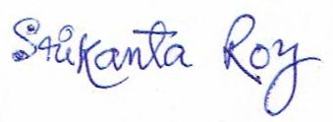

Date-
Place Signature of Candidate

