BIO- DATA

Name : Gobinda Das
Father’s Name : Kedar Das
Date Of Birth : 25/03/1998
Permanent Address : Vill- Sirni, P.O.- Keshrambha,
P.S.- Dantan, Dist- West Midnapur,Pin- 721451
Present Address : Do
Contact No. : 8016981788
Sex : Male
Caste : Genaral
Nationality : Indian
Religion : Hinduism
Educational Qualification : H.S.(Passed)
Technical Qualification : Certificate Course In Computer (It Smart)
Language Known : Bengali, Hindi, English
Hobby : Listen Song, Cricket

Place : Dantan
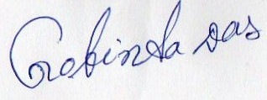
Date : 19/05/2018 Signature Of Student

