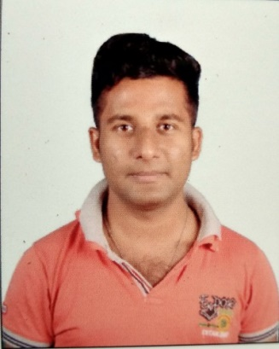
RESUME
NAME- HEMANTA HAZARI
FATHER’S NAME- SUJIT HAZARI
D.O.B—05-12-1996
ADDRESS—
VIL: MELERA
PO: MELERA
PS: BARIKUL
DIST: BANKURA
PIN: 722162
STATE-WEST BENGAL
CONTACT NO:8016034569,9564313514
E-MAIL:hazarih3@gmail.com
EDUCATION QUALIFICATION
EXAM PASSED | NAME OF THE BOARD | YEAR | MARKS
M.P | W.B.B.S.E | 2012 | 66%
H.S(SCIENCE) | W.B.C.H.S.E | 2014 | 58%
B.SC (3RD YEAR)Result waited | VIDYASAGAR UNIVERSITY | 2018
EXTRA QUALIFICATION- 6 MONTH Computer Diploma in Informatio Technology (IT) & One year advance diploma in Tally Application(ADFA)
HOBBIES- TRAVELLING AND NET SURFING
LANGUAGE KNOWN-BENGALI,ENGLISH,HINDI
NATIONALITY-INDIAN
RELIGION-HINDUISM
CASTE-GENERAL
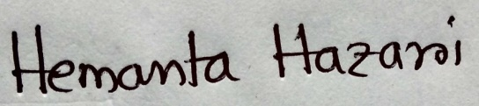
I hereby declare that the above mentioned detais are true and correct best of my knowledge and belief.

