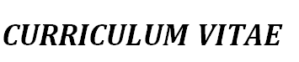
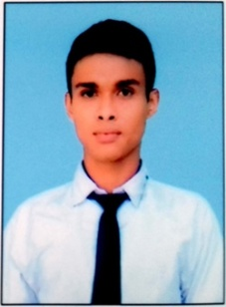
ARUP MISTRI
EMAIL ID :-arupmistri.am@gmail.com
VILL-CHHOTOKHEJURIA, P.O-ADCCONAGAR
P.S.-MOGRA, DIST-HOOGHLY
PIN- 712121
MOBILE: 8013421443
CAREER OBJECTIVE
To seek a challenging position in my job field where I can utilize my analytical and
Effective team work capabilities in favor of the organization.
PERSONAL PROFILE Father's name :- Shyamapada Mistri
Mother’s name :- Malina Mistri
Date of birth :- 18.04.1995
Nationality :- Indian
Language :- Bengali, Hindi & English
Marital status :- Unmarried
Religion :- Hindu
Hobby :- Playing football
EDUCATIONAL QUALIFICATION
EXAMINATION | BOARD / UNIVERSITY | PERCENTAGE | YEAR
10th | W.B.B.S.E | 54.50 | 2011
12th | W.B.C.H.S.E | 76.40 | 2013
B.A.(Geography) | UNIVERSITY OF BURDWAN | 52.50 | 2016

COMPUTER & TECHNICAL QUALIFICATION * IT SMART
- IT Tools & Information Technologies/MS Office Word 2007/MS Office Excel 2007/MS Office
Access2007/MS Office Power Point 2007.( HTML,XHTML,DHTML,CSS,XML,JAVA SCRIPT,ASP,
PHP) From APLL at 6Months .
* HOSPITALITY MANAGEMENT
- Hospitality Management From 7th January to 7th March 2017 at DON BOSCO TECH,BANDEL
HOOGHLY,WESTBENGAL-712103.

DECLARATION
I here by declare that the information furnished above is true to the best of my knowledge and conscience.

DATE : 10th October
PLACE : Adisaptagram ARUP MISTRI

