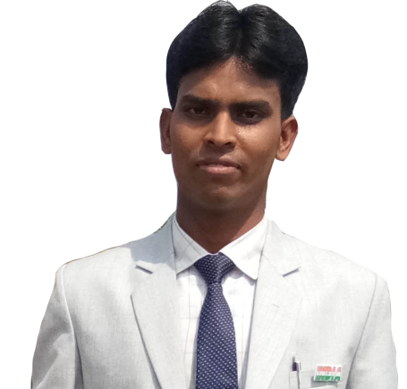
REERENCE
CERTIFICATION
INTERPERSONAL SKILLS

Bachelor of Arts
English Hons.(Appearing)
Intermediate
I Sc.(Biology) Swami vivekanand higher secondary school 2015-2017
Matric utkarmit high school manikpur 2015

Microsoft Word
Microsoft Powerpoint
Microsoft Excel
Microsoft Access
HTML & XHTML & DHTML
CSS & Java Script
XML & PHP & ASP

Communication Skills
Adobe CS
Team Management & leadership
Office Management

I am an individual seeking a office management position at a IT Sector(APLL C.C.C ) that will allow me to learn the process . I possess valuable skills with great performance that I believe make me best suited for the position of office management of my skills being mentioned below.

Apll Career Computer Center(Deoghar) |March 2017 – present office Management
I was held responsible for leading a team of creative people in office management performance. I was also managed to do quality checks for them.

Some of my interpersonal skills include the following.
.1 I am diligent and responsible boy.
.2 I am able to work alongside others harmoniously.
.3 I am an efficient team leader as well as effective team player.
.4 I am a listener and speaker.
.5 I am a best presentation maker.
. Certified in best edu tech company Asian Pacific Learning Leverage Ltd.

................................................. ...........................................................
SIGNATURE ........................................

bbbbbbbbbbb
OTHER SKILLS
EXPERTISE
EXPERIENCE
OBJECTIVE
EDUCATION
K
VISHWAJEET KUMAR DOB:- 05 March 1999
NEAR B I T COLLEGE ROAD KUNJISAR Age:- 19 year
JASIDIH DEOGHAR JHARKHAND Religion:- Hindu
E-mail ID- vishu814142@gmail.com Gender:- Male
Mob No:- +91 7033733951 Marital Status:- Single
9123136936 Nationality:- Indian

