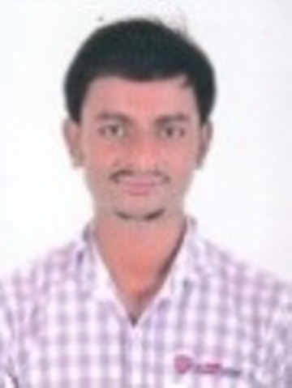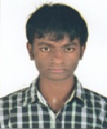

CURRICULAM VITAE
PATEL RAKESHKUMAR PREMJIBHAI

ADDRESS FOR COMMUNICATION

At – Post – Medhasan,
Ta – Modasa,
Dist – ARVALLI,
Mo. : 7600993145
Email:rakeshkumarpatel1996@gmail.com

PERSONAL DETAILS

Date of birth - 17/08/1996

Nationality - Indian

Marital Status - Single

Languages Known - Gujarati, Hindi & English

Hobbies - Cricket, Listening Music & Traveling

EDUCATIONAL QUALIFICATIONS

EXPERIENCE:- 6 MONTH COMPUTER OPRETORE IN MODASA MAMLATDAR OFFICE IN JANSEVA KENDRA
AND 2 YEAR COMPUTERS OPERATING AND CASH DEPARTMENT JAMES AND JEWELLERY
Degree | Year of Passing | Board/University | Percentage/SPI
S.S.C. | March 2011 | G.S.E.B. | 45.00 %
H.S.C. | March 2013 | G.S.H.S.E.B | 60.85 %
B.COM | SEPTEMBER 2017 | MONAD UNIVERSITY | 64.66 %

DECLARATION:

I hereby declare that the above-mentioned data are true to the best of my knowledge and belief.

Yours truly,
(patel Rakesh)

