Curriculum Vitae
SOHAM ROY
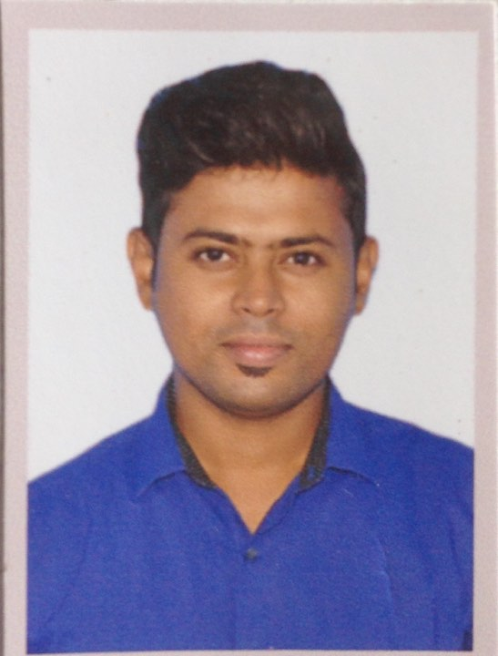

Permanent Address : 68/122/A/1 Jessore road, Amarpally.
Kolkata- 700074
Email Id : sohaam77@gmail.com
Contact No. : 9804977354 / 7980894770

CAREER OBJECTIVE:

To grow with a leading organization that utilizes my abilities to the fullest extent possible, helping me realize and develop my potential and be a part of a team that scales great heights through continuous learning process and utmost dedication.

ACADEMIC QUALIFICATION:
DEGREE /  CERTIFICATE | DEGREE | DISCIPLINE | INSTITUTE | BOARD /  UNIVERSITY | YEAR OF PASSING | AGGREGATE
10th | WBBSE |  | DUM DUM  SIKSHA NIKETAN  HIGH SCHOOL | West Bengal Board Of Secondary Education | 2007 | 65%
12th | WBBHSE |  | SahidRameswar  Vidyamandir | West Bengal Board Of Higher Secondary Education | 2009 | 60%
** Now I am doing Graduation ( B.A.sociologyHons. ) from Netaji Open University .

Professional Exposure:
- Doing a part time work in Event Management for last 4 years. First 2 years I have done so many works as a Management Supervisor and last 2 years even still i am doing part-time work in Event Management .

COMPUTER SKILLS:

- IT Tools & Information Technologies.
- Computer Fundamentals, MS OFFICE, Internet and Soft skills.
- HTML, XHTM, DHTML, CSS, XML, Java Script, ASP, PHP.
- Typing speed 110 wpm.

HOBBIES:
- Reading Cricket Books, Playing Cricket.
- Computer Games.
- Listening to Music.
- Traveling.

STRENGTH:
- Ability to manage change with easy, time and stress effectively.
- Good Interpersonal Relationship.
- Pay respect to everyone’s opinion.
- Man Management.
FAMILY DETAILS:
Relation | Name | Occupation
Father | SANKAR KUMAR ROY | Retired Service Man
Mother | SWAPNA ROY | House-wife
Siblings | RIMLI ROY | Job seeker

PERSONAL DETAILS:

Date of Birth : 10th MAY, 1989
Gender : Male
Mother tongue : Bengali
Nationality : Indian
Marital status : Unmarried
Languages : Bengali, English, Hindi
Location : Willing to relocate

DECLARATION:

I hereby notified to all that the information furnished above is true to the best of my knowledge and belief.

Date : Soham Roy

Place : KOLKATA Signature

