CURRICULUM VITAE

SUVENDU SHEE

Mobile | 9679409415 | E-mail Id | Suvendushee@gmail.com
Permanent  Address | C/O –SUVASH SHEE  Vill-Benapur  P.O-Benapur Chandanapara  P.S-Bagnan  Dist-Howrah  Pin-711312  West Bengal
  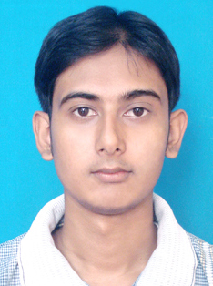

Academic Qualifications

Diploma in Web page design & basic |  | IT
Percentage |  | 60%
Session |  | 2013-2014
University |  | Other
Higher Secondary (10+2) |  | Benapur Chandanapara High School
Division / Percentage |  | 48.6
Year of Passing |  | 2011
Board |  | W.B.C.H.S.E
Secondary (10) |  | Benapur Chandanapara High School
Division / Percentage |  | 44
Year of Passing |  | 2009
Board |  | W.B.B.S.E
Personal Qualities

- Key Skills:Proficient Communication Skills (Bengali, English & Hindi) Discipline and punctual,

- Interests: Playing Cricket,Footbal,Listening Music,Searching internet

Training

- No Traning

Personal Profile

- Father’s name : Mr. SUVASH SHEE
- Mother’s name : Mrs. APARNA SHEE
- Sex : Male
- Date of birth : 8.3.1993
- Nationality : Indian
- Marital Status : Unmarried

Declaration

I hereby solemnly declare that all the information given above is true and correct to the best of my knowledge and belief.

Date:
Place: (Signature)

