RESUME
Name: Deepak Rabha
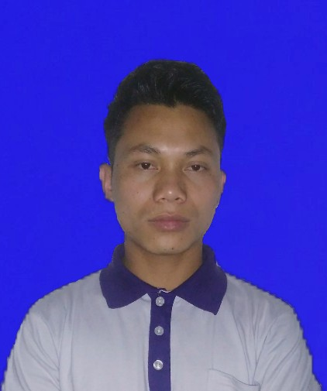
Mob No: +91 8812808726
E-mail: rabhadeepak456@gmail.com

Career Objectives

- To gain maximum knowledge from my superior through dedicated hard work
- To become professional in my profession

Personal Details

Name: Deepak Rabha
DOB: 21/06/1994
Vill: Nampathar
P.O: Gamerimura
P.S: Boko (Kamrup, Assam)
Pin Code: 781135
Gender: male
Marital Status: Unmarried

Educational Qualification

Sl.No | Qualification | Year of Passing | Board/University | Percentage  %
1 | B.A | 2015 | Gauhati University | 65
2 | H.S | 2012 | AHSEC | 49.98
3 | HSLC | 2010 | SEBA | 55.55

Additional Qualification

- IT Smart ( Web Designing )from APLL Ltd.(an ISO 9001:2008 Certified), Boko Centre.
- Accounts Assistant Using Tally (BCA & Tally ERP9) from ICA , Under DDU-GKY, Ministry of Rural Development, Govt. of India.

Strength

- Ability to Handle Manpower
- Good Family Support
- Good Presentation Skills

Hobbies

- Watching T.V and Motivational Videos
- Listening Music and Motivational Speech
- Playing Football

Declaration

I hereby declare that all the above mentioned information given by me are true to the best of my knowledge.

Date: Deepak Rabha
Place: Guwahati Signature

