CURRICULUM VITAE
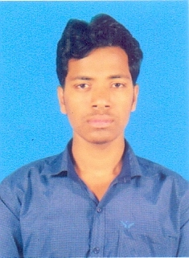
NAME : SUBHAJIT MANDAL
FATHER’S NAME : BHABATOSH MANDAL

PRESENT AND PERMANENT ADDRESS
VILL: - BIKRAMNAGAR P.O:- HERIA
P.S:- KHEJURI
DIST: - PURBA MEDINIPUR
STATE: - WEST BENGAL
PIN: - 721430
CONTACT INFO



MOB: - +91 9126870569 EMAIL: - subhajitmandal1000@gmail.com

EDUCATIONAL QUALIFICATION:-
NAME OF EXAM | BOARD/ UNIVERSITY | YEAR OF PASSING | % MARKS
M.P | W.B.B.S.E | 2010 | 52.00
H.S | W.B.S.C.V.E&T | 2012 | 58.67
B.C.A | VIDYASAGAR UNIVERSITY | 2015 | 51.01
IT & MANAGMENT | APLL | 2011 | 73.6

PRESONAL PERTICULARS :-
DATH OF BIRTH: - 17.05.1995
SEX: - MALE
STATUS: - SINGLE
LANGUAGE KNOWN: - BENGALI, HINDI, ENGLISH.
NATIONALITY: - INDIAN
RELIGION: - HINDUISM
CATEGORY: - SC

WORK EXPERIENCE:-
- 7 YEAR EXPERIENCE (DENNIS INFOTECH) IN HARDWEAR & NETWORKING AT PARK STREET, KOLKATA.
- 1 YEAR EXPERIENCE (QUICKNET CYBERCAFE) OFFICE MANEGMENTS AT HERIA, PURBA MEDINIPUR.

CARRIER OBJECTIVES:-
Aim to be associated with a progressive organization that gives scope to update my knowledge and skill in accordance with latest trends to be a part of term that dynamically work towards that growth of the organization & gain satisfaction there of strong faith in hard work loyalty and self confidence for a successfully carrier in life.

DECLARATION:-
I do here by declare that all the above mentioned information are true to the best of my knowledge & believe and I bear the responsibility for the correctness of the above mentioned particulars.

DATE:
PLACE: HERIA Signature

