+ 91 - 8296989827  + 91 - 8013133422  biswajitedber36@gmail.com |  |  |  |  |  |  |  | C/O – Miran Edber  Sarada pally, P.O – Gauranga nagar  P.S – New Town, Pin –700159,  West Bengal, India
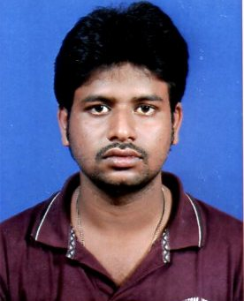

Biswajit Edber
OBJECTIVE |  |  |  | To associate with an organization where scope for contributing and learning are high. A challenging fast pace environment with healthy competitive culture would best suit me.
SYNOPSIS |  |  |  | - Successfully Completed B.E in Electrical Engineering from University Institute of Technology in 2016 with a zeal to excel in the field of Electrical Engineering  - A team player with outstanding communication and interpersonal skills.  - Competent in working with computers with good analytical ability.  - Ability to achieve organizational goals with keen interest in learning new things.
CAREER INTERESTS |  |  |  | - Energy and Electric Power  - Project Co-Ordinator  - Systems & Programmer  - Electrical Machine Design  - Power Theory  - Circuit Theory
SKILL SET |  |  |  | - Proficient in MS Office (Word, Excel, PowerPoint, Outlook)  - Well Versed with Operating Systems – Windows 2000/7/XP/Vista  - KNOWN AUTOCAD AND ENGINEERING DRWAING
ACADEMIC CREDENTIALS
Degree |  |  | Institute |  |  |  | University / Board |  | Year | % Marks
B. Tech (Electrical) |  |  | University Institute of Technology |  |  |  | The University |  | 2016 | 58%
 |  |  |  |  |  |  |  |  | 2013 | 67.5%
 |  |  |  |  |  |  |  |  | 2007 | 62.62%
TRAININGS UNDERTAKEN

ACADEMIC PROJECTS UNDERTAKEN |  |  |  | - Project Title : Automatic water level controller system , and Economical load flow dispatch  Platform Used : MATLAB  Project Details : Inverter  Duration : Ongoing Final Year Project
CHARACTERISTIC STRENGTHS |  |  |  | - Quick learning and implementing capability  - Good motivator and a pleasing personality.  - Effective Leadership qualities.  - Value for Quality & Time.  - Enthusiastic & fast learner.  - “Team work” approach towards achievement of collective goals.
PERSONAL DETAILS |  |  |  | Sex | Male
PERSONAL DETAILS |  |  |  | Date Of Birth | February 3, 1992
PERSONAL DETAILS |  |  |  | Marital Status | Single
PERSONAL DETAILS |  |  |  | Languages Known | English, Hindi, & Bengali
PERSONAL DETAILS |  |  |  | Personal Interests | Listening to Music, Travelling, Internet
Experience |  |  |  | ONE YEAR JOB EXPERIENCE IN KOLKATA METROPOLITON DEVELOPMENT AUTHORITY POST OF JUNIOR ENGINEER

