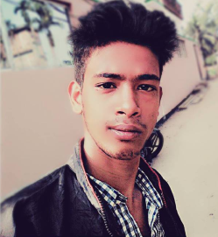
Curriculum Vitae
Name: Sanjoy Chandra Raha
Address: Indranagar, N.k.nagar, Agartala,
West Tripura, Pin:- 799006
Contact: 7005018842
Email id: Chrahasanjoy@gmail.com
Personal Overview:
Having a good communication skill and wanting to learn new things, I am looking forward to do job in a field where I can use my full potential. I am flexible enough to do job as per the situation demands. I am always passionate about what I do and I give my full to the work and enjoy it.
Qualification:
Name of the examination | Name Of the Institution | Board | Year of Passing | Percentage
Madhyamik | Noagaon Krishna Nagar High School | TBSE | 2013 | 39.28
Higher secondary | Prachaya Bhrati High Secondary School | TBSE | 2015 | 32.2

Skills: 1. Computer Skills
2. Communication Skills
Strengths: 1. Honest
2. Determined
Weakness: 1. Emotional
2. Pyrophobia
3. Fear of accident
4. Fear of deep water
Social Links:-
Facebook:- https://www.facebook.com/sanjoy.raha.79
Whatsapp:- 7005018842

I do hereby declare that the information given are correct as per my knowledge.

