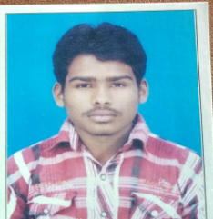
SUMON DAS RESUME
Sumon342@Gmail.Com
9563240296
PERSONAL DETAILS :-
D.O.B : 05/09/1999
C/O : Anil Das
Language Known : Bengali, English & Hindi
Cast : General
Religion : Hindu
Guardian Contact No. : 9563240296
Marital Status : Unmarried
ADDRESS :-
VILL : Sonatickry
P.O : Paniseola
P.S : Haripal
DIST : Hooghly
PIN : 712405
EDUCATION QUALIFICATION :-
Year Of Passing | Qualification | Specialization Or Subject | School /Collage /  University / Institute | Total  Marks % / Cgpa
Current | B’com(Honors) | Account | Nabagram hiralal paul collage (C.U) | N/A
2016 | Higher Secondary /12th | Accountancy | Tarakeswar High School (Wbbhse) | 312  (62.4%)
2014 | MADHYAMICK / 10th | Life Science | Maheshpur High School (Wbbse) | 234  (33.4%)
EXTRA QUALIFICATION :-
- Basic Computer, Microsoft Office Package(updated),Web Designing, Tally Erp9 (GST).
Experience:-
- 2 years in Accounts & Data Entry Operator at SAMPARKA CABLE NETWORK.
- 2 months Accounts at SCIENCE DOMAIN INTERNATIONAL.
LIFE GOAL :-
- Getting A Job In A good Company And Achieve The Top Position In There With Giving my best.
HOBBIES/INTEREST :-
- Playing Games, Surfing Internet, Online Chatting.
DECLARATION :-
I hereby declare that all the details mentioned in the resume are true & I shall furnish all the necessary certificates whenever required.

Place :- signature :-

date :-

