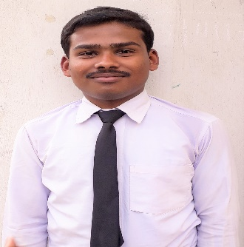
CURRICULUM VITAE
SUMON DAS
Mobile No: 9563240296
Email ID : sumond342@gmail.com

POSTAL ADDRESS:
Vill-Sonatickry, P.O-Panisheola, Dist-Hooghly, Pin-712405
ACADEMIC QUALIFICATION:
NAME OF EXAMINATION | BOARD/UNIVERSITY | YEAR OF PASSING
MADHYAMIK | W.B.B.S.E | 2014
HIGHER SECONDARY | W.B.C.H.S.E | 2016

CAREER OBJECTIVE:
A career opportunity that allow me to apply my education with my personal ability. Seeking a job where I will be able to fully utilize my skill and abilities in the industry that offers professional growth while being resourceful innovative and flexible.
EXTRA CURRICULUM ACTIVITIES:
- Retail Sales Associate
COMPUTER KNOWLEDGE:
- Basic Fundamentals of Computer with Microsoft Office Packages.
- Web Designing.
- Tally Erp9.
CURRENT STATUS:
- Pursuing Retail Management from NABAGRAM HIRALAL PAUL COLLEGE.
WORK EXPERIENCE:
- 3 years’ experience in data entry operator at SAMPARKA CABLE NETWORK (Hathway Cable & Datacom Ltd).
- 15 days’ OJT at FBB KONNAGAR (Future Retail Ltd).
- 2 month OJT at SHOPERS STOP ( K Raheja Corp Group).

Thank PERSONAL DETAILS:
Name : Sumon Das
Father’s Name : Anil Das
Date of Birth : 05-09-1999
Mobile Number : 9563240296/7001132565
Sex : Male
Marital Status : Single
Category : General
Nationality : Indian
Language Known : Bengali, English, Hindi
Hobbies : Research new things about computers, Helping
People, Online Chatting

Sir, I do hereby declare that the particulars furnished above are true to the best of my knowledge.

Date : 31-05-2019
Place : Haripal (SUMON DAS)

