CURRICULUM -VITAE
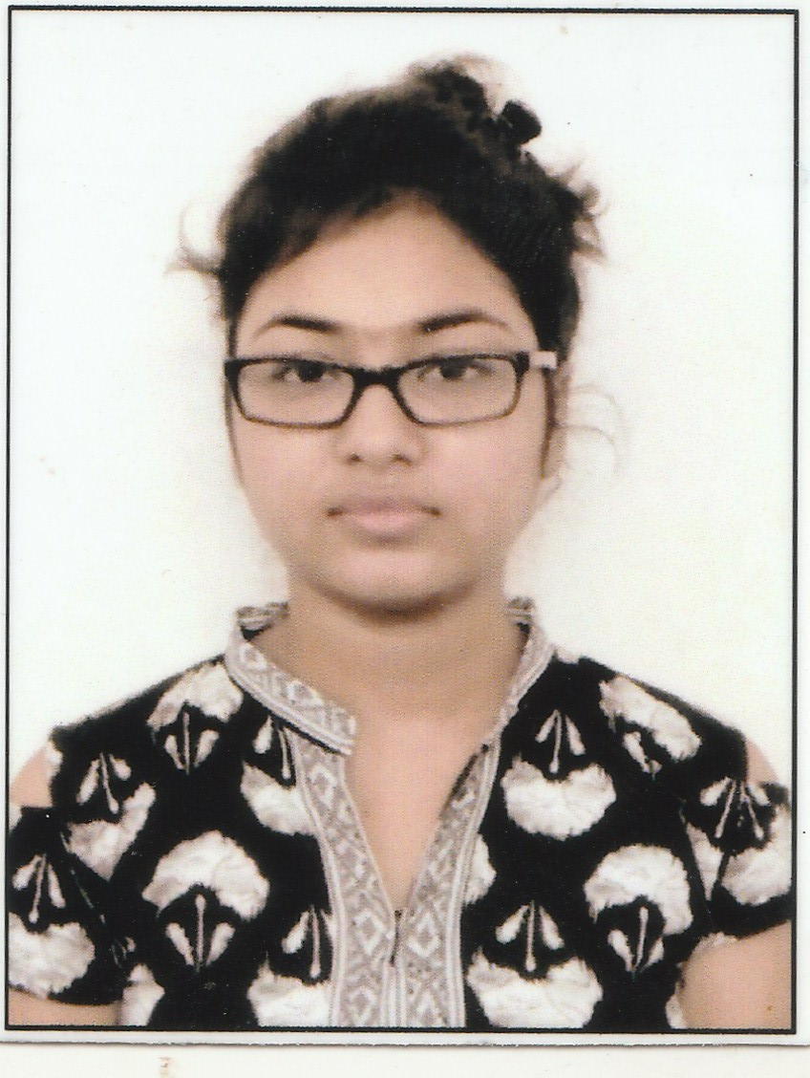
NAME : PRIYANKA SIL
FATHER'S NAME : LATE.KHOKAN SIL
ADDRESS : 7/88 SAHID NAGAR,DHAKURIA,
POST: HALTU ,P.S: GARFA
KOLKATA: 7000078
CONTACT : 8777271089
EDUCATIONAL QUALIFICATION:
EXAMINATION | BOARD/UNIVERSITY | YEAR OF PASSED | % OF MARKS
SECONDERY | W.B.B.S.E | 2011 | 60
H.S | W.B.C.H.S.E | 2013 | 64.5
GRADUATE(B.COM) | CU | 2017 | 39
PERSONAL DETAILS
- D.O.B : 03/02/1996
- GENDER : FEMALE
- CATEGORY : GENERAL
- RELIGION : HINDUISM
- NATIONALITY: INDIAN
TECHNICAL QUALIFICATION : CITA from Youth Computer Center & from IIDR. And another professional course IT SMART PLUS completed from APLL. Also completed a vocational course in Customer Relationship and Sales from Reach India Trust.
OTHER SKILL : completed a BEAUTICIAN course from West Bengal State Council Of Technical And Vocational Education And Skill Development.
HOBBY : Doing HANDCRAFTS, stitching.
WORK EXP. : 10 months in ANJALI JEWELLERS and 1 year 1 month at LIFE STYLE INTERNATIONAL pvt.ltd. and 1year at KOYEL ACADEMY.
I confirmed that the information provided by me is true to the best of my best knowledge and belief.
DATE-
Place-Kolkata SIGNATURE

