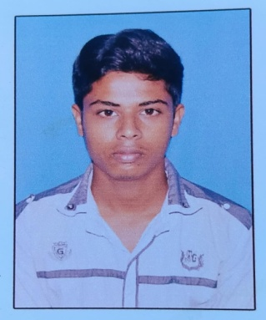
BIO-DATA

- NAME : BIKRAM NANDI
- FATHER’S NAME : BISWAJIT NANDI
- DATE OF BIRTH : 06/04/2001
- ADDRESS : NATUN COLONY CHOTONILPUR P.O-SRIPALLY,BARDHAMAN
- RELIGION : HINDU
- NATIONALITY : INDIAN
- GENDER : MALE
- MARTIAL STATUS : UNMARRIED
- CASTE : GENERAL
- PHONE : 8918260066
- EMAIL : bikramnandi91@gmail.com

EXAMINATION  PASSED | YEAR OF  PASSING | BOARD  SCHOOL/COLLEGE | FULL  MARKS | MARKS  OBTAINED
M.P | 2016 | W.B.B.S.E | 700 | 540
H.S | 2018 | W.B.C.H.S.E | 500 | 304

