Bio-Data

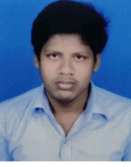
Personal information. PHOTO
Name:-. BISWAJIT MAL.
Father’s Name:-. NABAKUMAR MAL
Mother’s Name-. RINA MAL Gender:- MALE
Date of birth:-. 13/10/2001 Age:- 18 Caste:- SC
Blood group:-. B+ Marital status:-. SINGLE Nationality:- INDIAN
Addhar Number:- 768141324806
Language known:-
Name of the language | Read | Write | Speak
Bengali | Yes | Yes | Yes
English | YES | YES | NA
Hindi | NA | NA | YES

Address
Village:-. ARANDI Post office:-. ARANDI HOUSE NO:-. 200
Police Station:-. ARAMBAGH State:-. WEST BENGAL
District:-. HOOGHLY Pin:-. 712413
Country:-. INDIA

Communication
Mobile no:-. 8538022401
Email Id:-. 2001biswajit@gmail.com
Sl no | Name of the Exam | Examination Board | Year of passing | Group | Marks obtained
1 | Madhyamik  (10th) | WBBSE | 2017 | All subjects | 83.57
2 | Higher Secondary  (12th) | WBCHSE | 2019 | Science | 83.8
Educational Qualification

Computer literacy:- Ms word, Ms Excel, tally, Smart Commerce.

Certificate:- I hereby declare that the above statements make in this document are true to the best of my knowledge and belif.

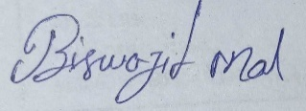
signature

