RESUME
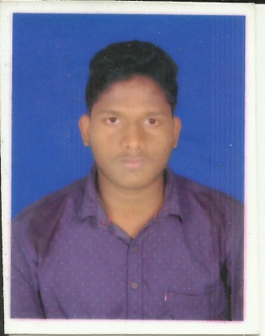

RATIRANJAN BHUYAN

L.T. COLONY, QR NO -37
At/Po- Charbatia
Dist-Cuttack
Pin- 754028
Mobile: 7504398272
EMAIL: ratiranjanbhuyan30496@gmail.com

EDUCATIONAL QUALIFICATION

.
Qualifying Exam | Board/  University | School/ College | Year of passing | Percentage
+3, science | UTKAL UNIVERSITY, ODISHA | Choudwar College,  Choudwar. | 2017 | 45%
+2, science | CHSE, ODISHA | Choudwar College,  Choudwar | 2014 | 44%
10th | BSE, ODISHA | Kalinga vidyapitha | 2011 | 60%

COMPUTER AWARENESS :-
- P.G.D.C.A.

SKILLS

- Ability to manage and work in a team effectively.
- Have a positive and growing attitude.
- Loyal to work and deal with problem patiently.
- Ability to adapt to different situation.

PERSONAL INFORMATION

- Date of Birth : 30TH april 1996
- Gender : Male
- Father’s name : Rabindranath Bhuyan
- Mother’s name : Parbati Bhuyan
- Nationality : Indian
- Languages : English, Hindi, Odia
- Permanent address : L.T. colony
Qr no 37
At/Po- Charbatia
Dist-cuttack
Pin-754028

DECLARATION

I do hereby declare that the information furnished above is true to the best of my knowledge and belief.

PLACE: Charbatia

DATE: RATIRANJAN BHUYAN

