CURRICULUM VITAE
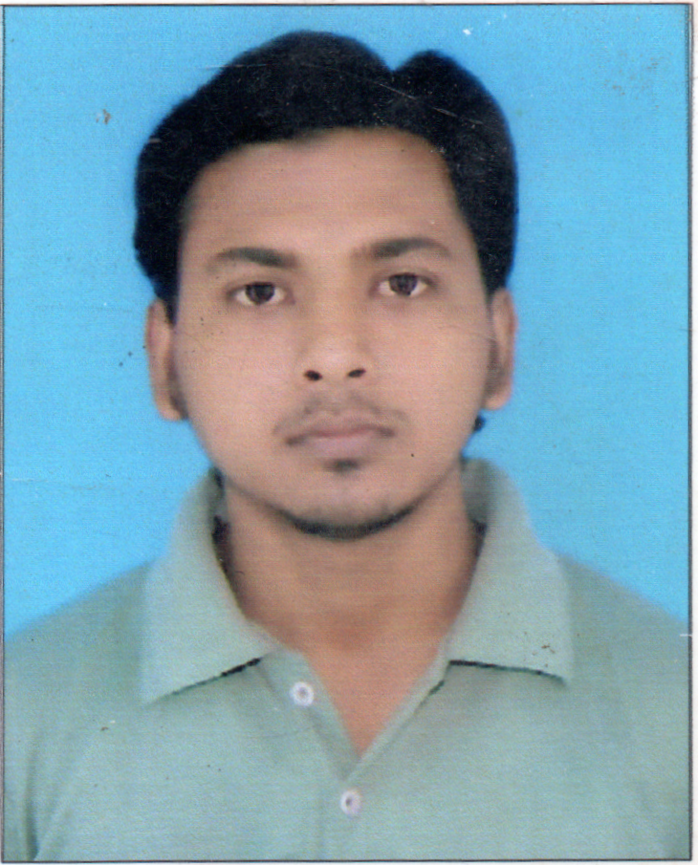
Manish Kumar Sharma
Address :Bhagwati Chauraha Lachchhipur Khas Post-Gorakhnath
Dist-Gorakhpur , Pin-273015
Contact No. – 9935632848,9260991990
CAREER OBJECTIVE :

Seeking civil site engineer, civil supervisor, civil coordinator, level assignments, were I can utilize my skills and knowledge.

Qualification | Board/University | Passing year
High School | U.P. Board | 2010
Intermediate | U.P. Board | 2012
Diploma | Arunachal University | 2016
B.tech (Civil Engg.) | J.S University | 2020
COMPUTER/HARDWARE SKILL:

Ms-Office2007, Email Browsing
Diploma in computer Application (DCA)
Auto CAD (Civil Engg.)
3D’s Max (Civil Engg.)
Course on Computer Concepts (CCC)
WORK EXPERIENCE:
One Month Summer Training P.W.D Department
One Year work in Highway Engg. & Structure work
SUMMARY OF JOB EXECUTION

Civil work and related various type of testing site ( Slump test, Compaction test of soil compressive strength test of soil Compressive strength test of Concrete etc.

KEY RESULT AREAS:
Quality Work
Civil Inspection
Structural Inspection
Material Inspection
Painting Inspection
STRENGHT:

Excellent Test Proficiency.
Effective Communication Skills.
Technical Report Writing Skills.
Ability to Work Extended Hours And Perform Multitasks.
Ability to Maintain Positive Relation With Client And Co-Worker.
SITE ISSUE:

Case.1 Transportation- Road Construction And Materials, Road Construction , Bridges
Case.2 Compaction Test- Compaction Test Of Soil Of Different Of Soil Layer Using
Calibrated Equipment And Experienced Person Result Will Be
Good And Satisfactory.
Case.3 Concrete Work- All Test Must Be Satisfactory At Site And Reinforcement As Well
Reinforcement.
PERSONAL DETAILS :

Father Name : Krishnanand Sharma
Date of Birth : 08/09/1994
Marital Status : Married
Religion : Hindu
Sex : Male
Nationality : Indian
Language : Hindi, English
DECLARATION :
I hereby declare that all the information stated above are true and correct the best of my knowledge and belief.

Date :
Place (Manish Kumar Sharma)

