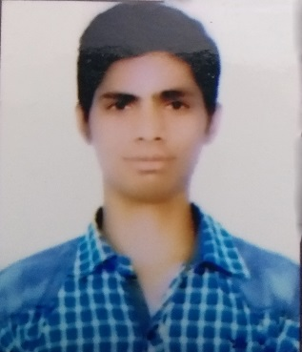
AKASH KUMAR SHRIVASTAV
H no-5a kh no-61/15 nangli vihar ext block c-3 gali no-2
new delhi-110043
Mo.no- 8285628588;
Mail ID - kumaraakash7835@gmail.com

SUMMARY

: A good communicator with advanced presentation skills possessing ability of
Working under tight dead line.
: Highly self-motivated and goal-oriented professional equipment to enter and
Operate in a professional.

ACADEMIC QUALIFICATION:

: 10th passed out from Delhi CBSE board 2014.
:12TH passed out from Delhi CBSE board 2016.
:B.A .final year.
: Computer advance knowledge & web design.
: typing speed 25-30 approx.

EXPIRIANCE-
: oppo mobile 2 year working.
: Home credit finance 7 months working.
: IDFC First bank in working.

PERSONAL DETAILS:
Date of birth : 08/07/1998
Father’s name : Shri Rajesh kumar Shrivastav
Mother’s name : Smt Usha devi
Marital status : Unmarried
Nationality : Indian
Language Known : Hindi,

Date-..../....../......
Place- { Akash kumar shrivastav }

