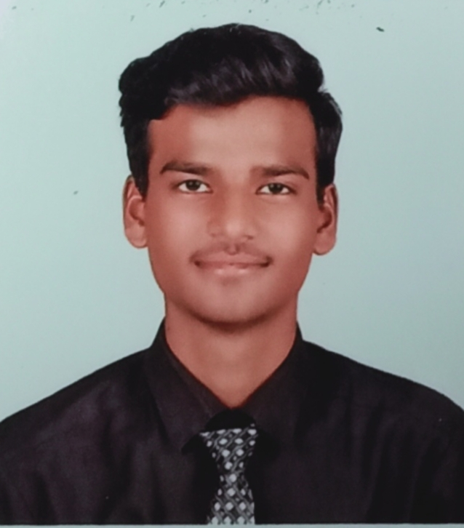AMIR

GOURI.

Village Pitawla dewas,Bhopal Road
Dewas – 455001

Ph.:7440738597
:9691873765
Mail: officialamirgouri@gmail.com

Seeking challenging position which effectively utilizes my skills and apply my knowledge and work dynamically towards the growth of an organization which provides an environment where ethics and talent reign supreme, leading to personal and professional growth.


ACADEMIC DETAILS
2016-17 Secondary Examination

S.N.V.M School

2018-19

Higher Secondary Examination
S.N.V.M School

2019-20 Graduation: Bsc(biotechnology) 1st year running



COMPUTER KNOWLEDGE.

● IT TOOLS AND INFORMATION TECHNOLOGY

●OPERATING SYSTEM WINDOWS

●ms office word

●ms power point

●ms excel

●ms access

●Intriduction internet and email

●Business accounting

●Pf and Esi

●E commerce

●M commerce

●Digitel marketing

●Diffrent digital applications

●Project


PERSONAL
PARTICULARS
Father : Mr. Ashiq gouri
Mother : Mrs Naseeb bee
Date of birth : 20/10/2001
Gender : Male
Languages known : Hindi & English
Nationality : Indian
Marital status : Single
Hobbies : music and improve P.D.

DECLARATION

I hereby declare that the above mentioned information is correct up to the best of my knowledge and belief; I bear the responsibility for the correctness of above mentioned.

Date:23-6-2020
Place: Dewas

Signature
(AMIR GOURI)

