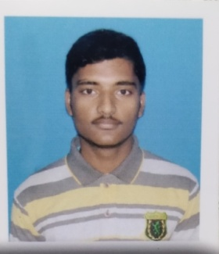
BIO-DATA
NAME-PARTHA SARATHI GOSWAMI
MOBILE NO: 8597865962
Email ID:parthagoswami545@gmail.com
PERSONAL DETAILS
NAME : PARTHA SARATHI GOSWAMI
FATHER’S NAME : ARUMOY GOSWAMI
MOTHER’S NAME :BIJAYA GOSWAMI
ADDRESS :VILL-Purbanarayanpur,P.O-Satberia,P.S-Kotalpur,Dist-Bankura,Pin-712612,State-
West Bengal.
Date of Birth : 23/10/2000
SEX :MALE
NATIONALITY :INDIAN
RELIGION :HINDU
CASTE :GENERAL
MARITAL STATUS :UNMARRIED
LANGUAGE KNOWN :BENGALI,
EDUCATIONAL QUALIFICATION
Exam Passed | Name of The Board/University | Year of Passing | Total Marks | Marks Obtain | Marks (%)
M.P. | W.B.B.S.E | 2017 | 700 | 422 | 60.28
H.S. | W.B.C.H.S.E | 2019 | 500 | 362 | 72.4

EXTRA QUALIFICATION : Diploma in Computer Application
DATE-22/06/2020

