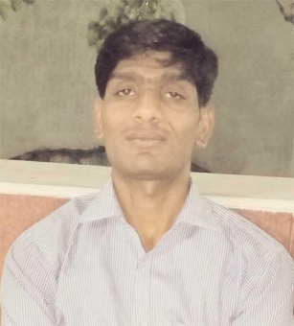
CURRICULUM-VITAE
Name :– Deepak Gurjar
Address :- village – Didali, Post- Chandwana,
Tehshil – : Khategaon , Dist- Dewas [M.P.]
Mob:- 8989662817
Email Id- d.k.gurjar3278@gmail.com

CARRER OBJECTIVE:- Any challenging Job where my qualification talent and skill
Could be utilization contribute to the goals of the organization and my personal

EDUCATION QUALIFICATION:-

S.N | Qualification | University/Board | Result | Year
1 | 12 th Maths | M.P. Board | 53.11% | 2012
2 | 10 th. | M.P. Board | 44 % | 2009

PROFESNAL EXPERIENCE;-

- Designation :-1 Year Experience in ACER Computer Installation Engineer
- 10 Month Tally Software Installation Indore
- 6 Month Haier India appliance Pvt. Computer Operator Indore
- 6 Month SEBI Registrated Company (Ethical Research) As Computer Engineer Indore

LANGUAGE KNOW:- Hindi , English

COMPUTER KNOW. Basic Knowledge: MS Word, Exel. Hardware Software

STRENGTH:-
- Effective community training skill to mobilize and motivate the farmer community
- Always believe in challenging and result orientated works with positive attitude
- Hard as well as smart working with sincere Devotion and dedication
- Working with honesty punctuality & determinant
PERSONAL INFORMATION:-
Name : Deepak Gurjar
Father’s Name : Narayan Gurjar
DOB : 08/07/1993
Gender : Male
Hobbies : Computer Operator
DECLARATION:-
I here by declare that all the above information furnished by me is true to the best of my knowledge
Place- khategaon

Date- -------------
Your faithfully
Deepak Gurjar

