CURRICULAM VITAE
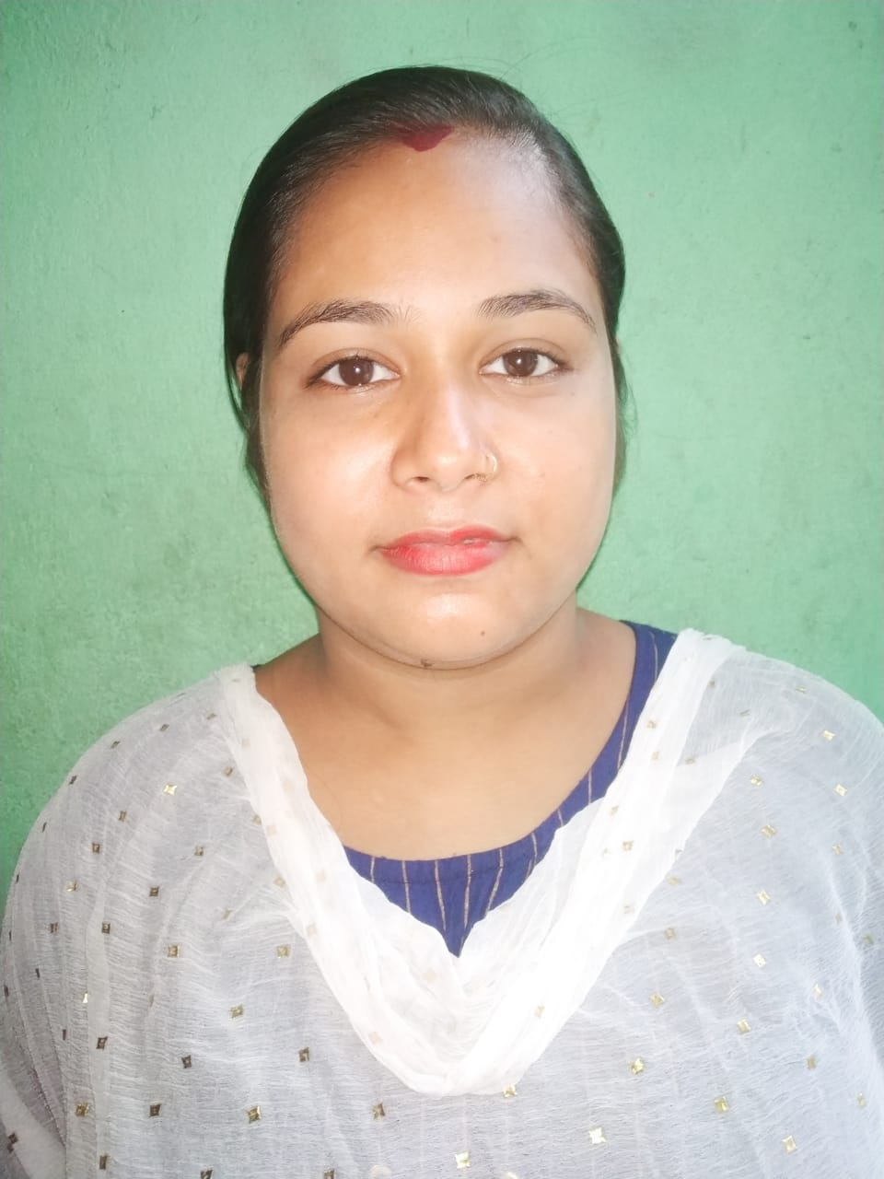
NAME : Madhumita Halder
FATHER’S NAME : Happy Halder
DATE OF BIRTH : 29/09/1998
ADDRESS : Garia ,Natun Diara, Ganga Joara Road,
P.S-Sonarpur,P.O-Nayabad,Kol-700150
NATIONALITY : INDIAN
RELIGION : HINDU
GENDER : FEMALE
PH. NO : 7980296023/ 8910571593
EMAIL ID : haldermadhumita090@gmail.com
CASTE : SC
EDUCATIONAL QUALIFICATION:
EXAM NAME BOARD NAME INSTITUTION NAME PASSING YEAR
MADHYAMIK W.B.B.S.C BALIA NAFAR CHANDRA BALIKA V. 2015
H.S W.B.C.H.S.E BALIA NAFAR CHANDRA BALIKA V. 2017
B.A C.U JOGOMAYA DEVI COLLAGE 2017-PRESENT
B.A C.U JOGOMAYA DEVI COLLAGE 2017 –PRESENT

COMPUTER KNOWLEDGE:
COURSE NAME INSTITUTION NAME GRADE PASSING YEAR
DIPLOMA, CDTP YOUTH COMPUTER TRAINING CENTRE B+ , A+ 2015,2016
SMART COMMERCE APLL B+ 2019

WORKING EXPERIENCE : YOUTH COMPUTER TRANING CENTER
LANGUAGE KNOWN : HINDI, ENGLISH, BENGALI
REFERENCE : TO BE FURNISHED ON REQUEST
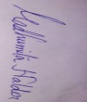
SIGNATURE:
PLACE: GARIA
DATE: 20/06/2020

