
BIO DATA
1.NAME: HEMANTA HAZARI
2.FATHER’S NAME: SUJIT HAZARI
3.MOTHER’S NAME: DURGA HAZARI
4.D.O.B: 05/12/1996
5.SEX: MALE
6.Present Address: MELERA
MELERA
BARIKUL
BANKURA
722162
7.Permanent Address: VILL:MELERA P.O:MELERA P.S:BARIKUL DIST:BANKURA PIN:722162 STATE:WEST BENGAL
8.CONTACT NO: 8016034569/9564313514
9.E.MAIL: hazarih3@gmail.com
10.NATIONALITY: Indian
11.BLOOD GROUP: O(+Ve)
12.LANGUAGE KNOWN: BENGALI, ENGLISH,HINDI
13.CASTE: General
14.RELIGION: Hindu
15.EDUCATION QUALIFICATION
NAME OF THE EXAMINATION | BOARD | YEAR | MARKS(%)
M.P | W.B.B.S.E | 2012 | 66.42
H.S(SCIENCE) | W.B.C.H.S.E | 2014 | 290
B.SC | VIDYASAGAR UNIVERSITY | 2018 | 56.42
16.EXTRA QUALIFICATION: 6 MONTH Computer Diploma in Informatio Technology (IT) & One year advance diploma in Tally Application(ADFA)
17.JOB EXPERIENCE: No
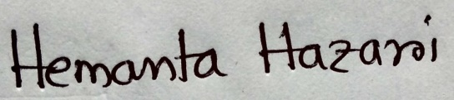
I hereby declare that the above mentioned details are true and correct best of my knowledge and belief.

