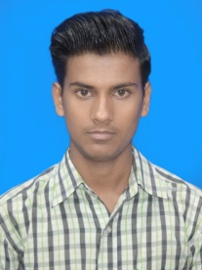
Resume

ShibnathBhagat
NarsinghBandh
MungeriaKhatal, Near Shiv Mandir
Dist- PaschimBurdwsan,Pin-713325
Contact No: - 8918005223
Email_ shibubhagt676@gmail.com
To become a successful professional where my sales skills, ability to understand and convey complex information, self-motivation, entrepreneurial spirit and results-driven work ethic will increase market share of "company name" productsas well as develop and save the quality of life.

CARRIER OBJECTIVE

EDUCATIONAL QUALIFICATION
►Higher Secondary (12th) (2018)
Completed with B.V.HighSchool (W.B.C.H.S.E)
► Secondary (10th) (2016):
Completed from B.V.HighSchool (W.B.B.S.E)
OTHER QUALIFICATION:

Basic Computer ( Software)

PERSONAL INFORMATION:

Date of birth: - 14th Feb 2000
Father’s name: - BinodBhagat
Permanent address: - NarsinghBandhMungeriaKhatal
Near Shiv Mandir,
Dist- PaschimBurdwsan,Pin -713325
Sex/Marital status: - Male/ unmarried
Nationality: - Indian
Languages known: Hindi/Bengali/English
Hobbies: - Playing cricket/Listening music/Reading Books

I do hereby declare that, all the above-mentioned statement
made by me is correct to the best of my knowledge and belief.

PLACE: ……………………………….
DATE: (Signature)

