SUSMITA KUNDU

MIDNAPORE , PASCHIM MEDINIPUR , WEST BENGAL

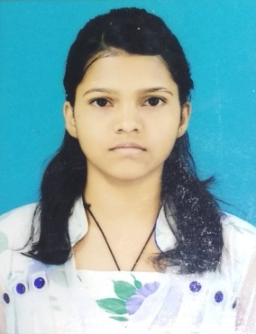
7479016711 * susmitakundu18dp@gmail.com

OBJECTIVES: Work for an organization which provides me the opportunity to improve my skills & knowledge to growth along with the organization objective.

EXPERIENCE: Freshers

EDUCATION QUALIFICATION:
Name of Examination | Year of Passing | Name of Board
Madhyamik (Class X) | 2015 | West Bengal Board Of Secondary Education
Higher Secondary (10+2) | 2017 | West Bengal Board Of Higher Secondary Education
Diploma In Computer Science & Technology | Pursuing | West Bengal State Council Of Technical & Vocational Education & Skill Development

EXTRA QUALIFICATION :
- Diploma in Information Application
- HTML
- GST
- Tally with ERP 9

