CURRICULUM VITAE

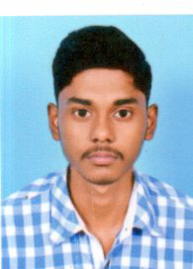
NAME : PRITAM KUMAR BHANDARI
FATHER’S NAME : PRABIR KUMAR BHANDARI
DATE OF BIRTH : 31/01/2000
PERMANENT ADDRESS VILL-SAHID KSHUDIRAM NAGAR
P.O-HATIBERIA
P.S:- HALDIA
DIST. - PURBA MEDINIPUR
PIN-721657(WB)
CONTACT NO : 9564214505
NATIONALITY : INDIAN
RELIGION : HINDUSIM
CASTE : GENERAL
SEX : MALE
MARITAL STATUS : UNMARRIED
LANGUAGE KNOWN AS : BENGALI & ENGLISH, HINDI
EMAIL ID : pritamkumarbhandari0@gmail.com

EDUCATIONAL QUALIFICATION:-

EXAMINATION PASSED | BOARD/COUNCIL/  UNIVERSITY | YEAR OF PASSING | MARKAS OBTAINED | PERCENTAGE OF MARKS
MADHYAMIK | W.B.B.S.E. | 2016 | 410 | 58.57%
HIGHER SECONDERY | W.B.C.H.S.E | 2018 | 379 | 75.8%

EXTRA QUALIFICATION: - COMPUTER DIPLOMA COURSE ,IT SMART PLUS.

DECLARATION:-
I do hereby declare that the all information given above are purely true and correct
to the best of my knowledge& belief.

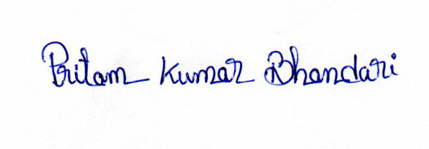
DATE:

PLACE: HALDIA Signature of the candidate

