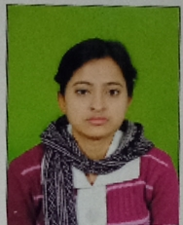
BANASREE BERA
Address: panskura, purba medinipur
Mobile no: 7001253435
Personal information:-
Name : Banasree Bera
Father’s name: Bharat Bera
Mother’s name: Susama Bera
Date of birth: 05/12 /1996
Sex: Female
Address: Vill: Dakshin katal
P.o+p.s: Panskura
Dist: purba medinipur
Pin: 721139
Nationality: Indian
Religion: Hindu
Cast: General
Mobile No: 7001253435
Email address: banasreebera4@gmail.com
Education Qualification:
Exam passed | Year passed | Board | persentange
Graduation in BCA | 2019 | Vidyasagar University | 56.74
H.S | 2016 | W.B.C.H.S.E | 72.2
M.P | 2014 | W.B.B.S.E | 70.29
Additional qualification:-
- Diploma of Elementary Education (D.EL.ED) FROM Panskura primary teachers training institute, purba medinipur.
Computer knowledge:-
- Diploma in computer Application (DCA)(Computer fundamental, MS-DOS,MS -OFFICE).
- Diploma in desktop publishing (DDTP).

LANGUAGE:-
- Bengali ,Hindi
Declaration:-I hereby declare that all above details information are true of my knowledge.
Banasree bera
Signature

