CURRICULUM VITAE
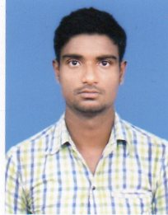

RAMESH SAHU

6/4 KELVIN LINE, ROOM NO. 260
P.O-TALPUKUR, BARRACKPORE
KOLKATA-700123
Mob – 9007549218/7003127175
Mail – rameshsahu602@gmail.com

ACADEMIC QUALIFICATION

- Graduation Running.
- Passed High Secondary Arts from WEST BENGAL COUNCIL OF HIGHER SECONDARY EDUCATION in the year 2015.
- Passed Matriculation From WEST BENGAL BOARD OF SECONDARY EDUCATION in the Year 2012 with.
- .
OTHER QUALIFICATION

Passed the Diploma in Information Technology Application.

OBJECTIVE

To be associated with an organization where I can contribute
my skills for the growth and benefit of the company.

PERSONAL DETAILS

Date of Birth : 03.04.1996
Father’s Name : Ram Chandra Sahu
Sex : Male
Marital Status : Unmarried
Nationality : Indian
Religion : Hinduism
Language Known : Oriya,Bengali,Hindi & English.
Strength : Confidence, Discipline & Hard work

Declaration

I hereby declare that all the given information furnished above is true and complete in all respect to the best of my knowledge.

------------------------------
Date: signature

Place: Barrackpore

