R E S U M E
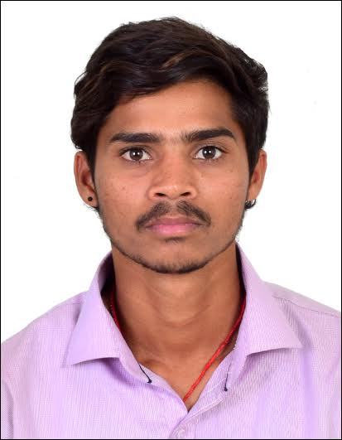

POST APPLIED FOR : O/S
NAME : RAMBABU GANAGALLA
FATHER’S NAME : GURAYYA GANAGALLA
DATE & PLACE OF BIRTH : 05.09.1999 / BANDARUVANIPETA, A.P.
MARITIAL STATUS : UNMARRIED
NATIONALITY / RELIGION : INDIAN / HINDU
EDU. QUALIFICATION : S.S.C. PASSED
LANGUAGES KNOWN : HINDI , ENGLISH & TELUGU

PERMANENT ADDRESS | PRESENT ADDRESS
1-137, DUMMU VEEDHI  BANDARUVANIPETA, SRIKAKULAM DIST ,  ANDHRA PRADESH – 532406.  CELL +91 9100306440 | ROOM NO. 128, SHIVDAS CHAMPSI MARG, CENTRAL RAILWAY COMPOUND, TADWADI, MAZGAON, MUMBAI – 400 010.  CELL: +91 9100306440  EMAIL : rambabugangalla999@gmail.com

DOCUMENTS DETAILS
DOCUMENTS | NO. | DATE OF ISSUE | PLACE OF ISSUE | VALIDITY
PASSPORT | R 5892986 | 29.09.2017 | VISAKHAPATNAM | 28.09.2027
CDC INDIAN | MUM 337686 | 27.10.2018 | MUMBAI | 26.10.228
INDOS | 18GL1923 | 12.01.2018 | MUMBAI | LIFE
YELLOW FEVER | 14511 | 10.12.2018 | MUMBAI | LIFE
WATCH KEEPING | WKN19000082 | 22.10.2019 | MUMBAI | LIFE

STCW 2010’ COURSES
COURSES | NO. | DATE OF ISSUE | PLACE OF ISSUE
GP RATING | G180M04035/JUN18/63276 | 03.08.2018 | HYDERABAD
PRE-SEA | CAA/GP/31/1317/2018 | 30.06.2018 | HYDERABAD
E.F.A. | CA/FFA/7107/2018 | 18.04.2018 | HYDERABAD
P.S.S.R. | CAA//PSSR/6394/2018 | 14.04.2018 | HYDERABAD
F.P.F.F. | CAA/FPFF/2289/2018 | 07.04.2018 | HYDERABAD
P.S.T. | CAA/PST/6459/2018 | 28.04.2018 | HYDERABAD
O.T.C.T.O. | CAA/OCTCO/359/2018 | 26.05.2018 | HYDERABAD
S.T.S.D.S.D. | CAA/STSDSD/3206/2018 | 10.04.2018 | HYDERABAD
DCE OIL& CHE | COPDGSOAC1911581 | 18.12.2019 | MUMBAI
SEA SERVICE
COMPANY | VESSELL | GRT | NRT | RANK | FROM | TO
CORAL REEF NAVIGATION | MV GHAZNAVI | 1330 | 1735T | OS | 04.02.2019 | 31.08.2019
DATE :

PLACE : MUMBAI RAMBABU GANAGALLA

