CURRICULUM-VITAE
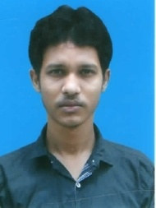

ALOKE MONDAL

Vill – Chandanpur, P.O. – Raipur
Dist – Birbhum, Pin – 731204 (W.B.)
Contact No –7063825068
Email – alokmondal848@gmail.com
Educational Qualification: -
EXAMINATION |  | BOARD / UNIVERSITY | YEAR | MARKS
- Madhyamik |  | W.B.B.S.E. | 2012 | 48%
- Higher Secondary |  | W.B.C.H.S.E | 2014 | 35%
Technical & Computer Knowledge: -
- Basic computer 6 months
- Diploma in Computer Web Design
- Hardware and networking 6 months cores utkarsh bangla
Personal Information: -
- Date of Birth | 14/12/1995
- Father’s Name | Santosh Mondal
- Nationality | Indian
- Religion | Hindu
- Marital Statue | Unmarried
- Sex | Male
- Community | General
- LanguageKnown | Bengali, Hindi & English
Declaration: -
I do hereby declare that all the statements declared above are true to my knowledge.

Date: -

Place: -
Signature

