CARRICULAM-VITAEL
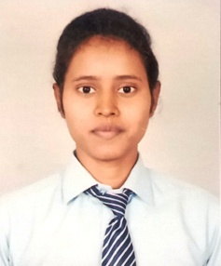
LAXMI GAUTAM
ADD.- Vikas Nagar, sector- 8, Lucknow,
Uttar Pradesh, Pincode -266022
Mobile No.- 8840014166
Email- laxmigautam053@gmail.com

CAREER OBJECTIVE-

To work in any circumstances where I can use my ability to the fullest and produce results that are best for me as well as the organization.

ACADEMIC QUALIFICATION –

- High School passed from UP Board in 2016.
- Intermediate passed from UP Board in 2018.
- Pursuing B.B.A form Bora institute of Management Sciences Lucknow .

COMPUTER KNOWLEDGE–

- Basic knowledge of computer .
- Tally.

PERSONAL SKILLS-

- Self Motivated
- Ability to take with the team
- Good Communication Skill

EXTAR CARRICULAM ACTIVITES-

- Conducted Successful “Trade Carnival” at BIMS Lucknow in the year 2018&2019 respectively.

- Achieved the Certificate of Dream Zone interior design & Fashion Design.

PERSONAL DETAILS-

Date of Birth : 25/12/1999
Husband Name : Late Mr. Moti Lal
Gender : Female
Nationality : Indian
Marital Status : Unmarried
Language Known : Hindi, English

DECLARATION-
I hereby declare that all statements made in this document are true, correct to the best of my knowledge, and believe.

Date:
Place : LAXMI GAUTAM

