RESUME
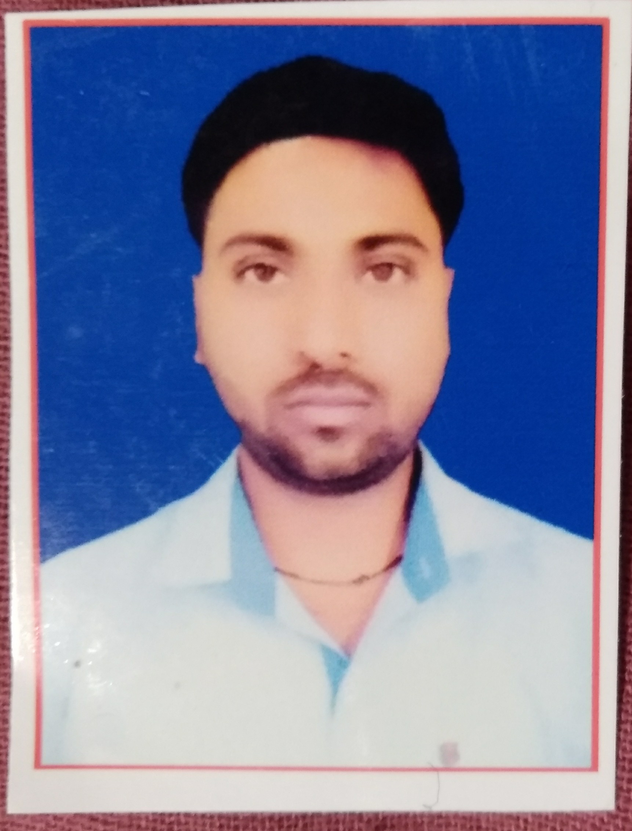
Name- RADHESHYAM SAH Email Id: - rrsp149@gmail.com
Contacts +91-8439068197, 9931142425

Carrier Objectiive:
- To work in a competitive and challenging environment in which I will utilize my technical & analytical skill for the growth of the organization.
Academic Qualification:
- High school passed with 1st Division from BSEB, PATNA in 2009.
- Intermediate passed with 2st Division from BSEB PATNA in 2011.
- Graduation passed with 2nd Division from LMNU, Darbhanga in 2014.
Computer Awerness:

- 6 months diploma computer in designing course and DCA knowledge.
- English Typing knowledge from 1 year
Hobbie :
- Playing Cricket , Listening and Internet surfing,

Personal Details:
Name RADHESHYAM SAH Gender Male Father’s Name Mr. Rameshwar sah Date Of Birth 25-12-1993 Mobile No. 8439068197 , 7004399438 Nationality Indian Languages Hindi, English.

Strengths:
- Hard working, Optimistic, Self confident.
- Flexible and believe in teamwork.
- Having good Communication skills.
- Willingness to learn new thing.
- Honestly for my work.
Declaration: I here by declare that all the information given above is true to best of my knowle
DATE:-
(RADHESHYAM SAH)

