MY RESUME

PARMANENT ADDRESS
VILL+POST-BABHANGAMA
WARD NO:-07
P. S:-RIGA DISTRICT:-SITAMARHI
PIN CODE:-843327
(BIHAR)
SAME AS PRESENT ADDRESS
EDUCATION QUALLIFICATION
CLAAS | BOARD | MARKS | PERSENTAGE | DIVISION | PASSING YEAR
10Th | BSEB | 430 | 86 | 1ST | 2019
12TH | BSEB | 391 | 78.2 | 1ST | 2021
PROFESSIONAL ADDRESS
SMART COMMERCE(COMPUTER)
FROM :-APLL INSITUTE
EXPERIENCE:-6MONTH
PERSONAL ADDRESS
MANI BHUSHAN SAHNI
FATHER'NAME:-BHOGENDRA SAHNI
D. O. B:-06/06/2002
SEX:-MALE
AGE:-19 YEARS
MARTIAL STATUS:-UNMARRED
RELIGION;-INDIAN
LANGUAGE:-HINDI, ENGLISH
ADHAR NO:-4587 1231 2401
CONTACT NO:-8294938217, 7827312419
EMAIL ID:-manibhushansahni@gmail.com
DECLARATION:-HEREBY DECLARE THAT THE FURNISHIED DETAIL ARE TRUE TO THE BEST OF MY KNOLEDGE.
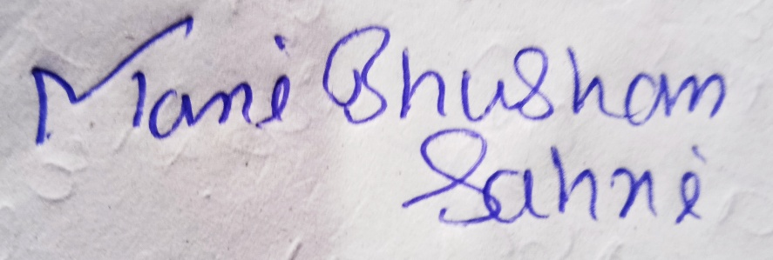
SIGNATURE
PLACE:-SITAMARHI

