CURRICULUM VITAE
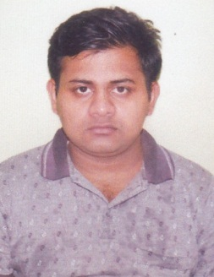
ABHISHEK BISWAS
Vill. : Koyra Hemanta Basu Nagar
Post. : Kadambagachi
P.S. : Duttapukur
Dist : North 24 Parganas
Pin : 700125
Contact No .- 7278439214

EDUCATIONAL QUALIFICATION :
GENERAL :
SL.NO. | EXAM. PASSED | YEAR OF PASSING | BOARD / COUNCIL | % OF MARKS
1 | Secondary | 2014 | WBBSE | 63.43
2 | Higher Secondary | 2016 | WBCHSE | 81.2

OTHER’S QUALIFICATION : BASIC COMPUTER

WORKING EXPERIENCE: 6 MONTH WORKING FROM KFC

PERSONAL DETAILS:
S/O : LATE KARTICK CHANDRA BISWAS
DOB : 03RD SEP 1999
SEX : MALE
CAST : GENERAL
MARITAL STATUS : SINGLE
RELEGION : HINDUISM
NATIONALITY : INDIAN
LANGUAGE : BANGALI, HINDI, ENGLISH
HOBBY : LISTEN MUSIC

CAREER OBJECTIVE:
To utilize my knowledge and skills to perform a respective and challenging job with prospective career
DECLEARATION :
I, hereby declare that all the above mentioned data are true to the best of my knowledge.

DATE :

PLACE : SIGNATUE OF THE CANDIDATE

