CURRICULUM VITAE
NAME: MD ARIF  CORRESPONDANCE ADDRESS:  VILL+PO- UJUNIA, PS- SALAR, DISTT- MURSHIDABAD, STATE- WEST BENGAL  ZIP CODE: 742401  CONTACT NO.:  +9  1-7319388382(CANDIDATE)  +91-9781807726 (FATHER)  EMAIL ID: mdarif8640@gmail.com | 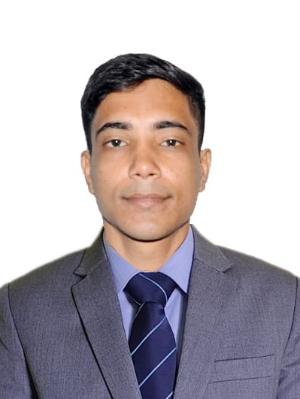  PROFESSIONAL AND EDUCATIONAL QUALIFICATION  - CURRENTLY PURSUING BACHELOR OF SCIENCE IN HOSPITALITY AND HOTEL ADMINISTRATION FROM INSTITUTE OF HOTEL MANAGEMENT GURDASPUR AND WILL BE COMPLETING IN THE YEAR 2022.  - I HAD COMPLETED MY 3-YEAR OF BACHELOR OF ARTS DEGREE FROM UNIVERSITY OF KALYANI IN THE YEAR OF 2019.  - I HAD COMPLETED MY SENIOR SECONDARY SCHOOLING FROM WEST BENGAL BOARD OF HIGHER SECONDARY EDUCATION WITH ARTS BACKGROUND IN THE YEAR OF 2015.  - I HAD COMPLETED MY MATRICULATION FROM WEST BENGAL BOARD OF SECONDARY EDUCATION IN THE YEAR OF 2013.
CARRER OBJECTIVE  TO SECURE A CHALLENGING POSITION IN A REPUTED ORGANISATION TO EXPAND MY LEARNING, KNOWLEDGE & SKILLS. | INDUSTRIAL EXPOSURE TRANING  GAINED A VALUABLE EXPERIENCE OF REAL TIME WORKING IN 4 STAR PROPERTY DURING MY 12 WEEKS INTERNSHIP.  I GOT OPPORTUNITY TO WORK WITH BEST WESTERN PLUS JALANDHAR TO UNDERSTAND FINER ASPECTS OF 4 STAR PROPERTY WAY OF FUNCTION DURING THE TIME. I GOT EXPOSURE TO ALL KEY DEPARTMENTS, THEREBY IMPROVE MY INSIGHT AS HOTEL MANAGEMENT PROFESSIONAL.
KEY ATTRIBUTES  - LOYALTY  - TECHNICAL COMPETENCY  - FLEXIBILITY  - PUNCTUALITY  - LEADERSHIP | EXTRA CURRICULAR ACTIVITIES & HOBBIES  - I HAD COMPLETED DIPLOMA IN COMPUTER APPLICATION.  - I LOVE PLAYING FOOTBALL  - I LOVE PLAYING CRICKET  - I LOVE SING
PERSONAL DEATAILS  FATHER’S NAME: ABDUL SALAM  D.O.B: 01/01/1998  PASSPORT NO.: P7740277  HEIGHT: 5’7’’  WEIGHT: 58 KG  EYE SIGHT: 6/6 | SPECIAL ACHIVEMENTS  1. PLAYED DISTRICT LEVEL TOURNAMENT IN FOOTBALL.
EDUCATIONAL REFERENCE  NAME: MR. ASHWANI KACHROO  DESIGNATION: HEAD OF DEPARTMENT ( IHM GURDASPUR )  EMAIL ID: ashkac67@gmail.com  CONTACT NO.: +91-9888825351 | PROFESSIONAL REFERENCE  NAME: MR. RAVI KUMAR  DESIGNATION: HOUSEKEEPING MANAGER(BEST WESTERN PLUS JALANDHAR)  EMAIL ID: ehk@bwplusjalandhar.in  CONTACT NO.: +91-7018297900

DECLARATION: I HEREBY DECLARE THAT THE ABOVE FURNISHED INFORMATION IS TRUE & BEST TO MY KNOWLEDGE.

DATE: -------------------------
PLACE: NAME: MD ARIF

