CURRICULUM VITAE(CV)

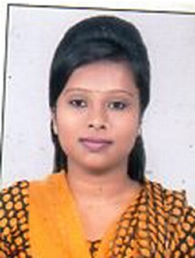
Career Objective:

To be a part of an organization to gain new knowledge and learn from daily works as well as use my skills which can be beneficial for the organization.

Personal Details:
Name : Sumita Rahul
Father’s Name : Lakhindar Rahul
Date of Birth : 02/10/1998
Gender : FEMALE
Languages Known. : BENGALI, HINDI, ENGLISH
Able to Speak : Bengali , Hindi
Able to write : Bengali, English, Hindi
Permanent Address : Subhasgram Chanditala Park, P.O.-Subhasgram, P.S-Sonarpur, District- South 24 Pargana, Pin- 700147
Mobile No: 7980206478
Mail Address : sumitarahulpresi@gmail.com
Academic Qualification:

Qualification | Board / University | Year of Passing | Marks (in %)
PG | PRESIDENCY UNIVERSITY | 2020 | 56.05
UG | CALCUTTA UNIVERSITY | 2018 | 60.62
12th | W.B.C.H.S.E | 2015 | 68.40
10th | W.B.B.S.E | 2013 | 57.14

Computer Proficiency :

- Basics of computer
- IT Smart Course with certificate

Working Experience : No Experience

THANK YOU

