BIO - DATA
NAME – SK JAHIR ALI
C/O - SK REJAK
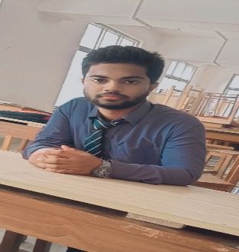
MOTHER’S NAME – JAHANARA KHATUN
PERMANENT ADDRESS :-

VILL :- HORSUNA
P.O :- SIMLON
P.S : - KALNA
DIST:- PURBA BARDHAMAN
PIN : - 713425
PRESENT ADDRESS : DO
STATE : - WEST BENGAL
DATE OF BIRTH :- 31/10/2005
CONTACT NO : - 6295383599
Email ID :- rasidsk222@gmail.com
GENDER :- MALE
NATIONALITY :- INDIAN
RELIGION :- ISLAM
CATEGORY : - OBC-A
MARRIETAL STATUS : - UNMARRIED
LANGUAGES :- BENGALI , HINDI

EDUCATIONAL QUALIFICATION :
Name | Name of Board | Year of passing | Percentage (%)
Madhyamik | W.B.B.S.E | 2020 | 38
H.S | W.B.C.H.S.E | 2022 | 72.2
PERSONAL CHARACTERSTIC : - SINCERE , DETERMINANT AND HARD WORKING .EXTRA QUALIFICATION : DIPLOMA IN COMPUTER APPLICATION (DITA) .

DECLARATION : I hereby declare that the above mentioned information is correct up to my knowledge and bear the responsibility for that correctness of the above mentioned particulars.

