BIO DATA OF MAYURI
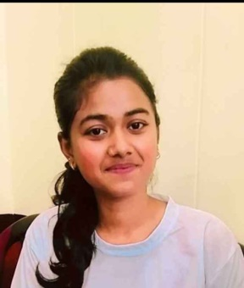

1. OBJECTIVE:
A position as an active employee, involving responsibility and working with each other as a team member to achieve organisational goal
2. GENERAL INFORMATION:
NAME | MS. Mayuri gupta
DATE OF BIRTH | 30-01-2002
ADDRESS | 1896/668 upranganj near tamarhai school Jabalpur M.P.
CONTACT NO. | 9407821788
EMAIL | Mayurigupta094@gmail.com
LANGUAGE KNOWN | English , Hindi

3. EDUCATIONAL QUALIFICATION :
S. NO. | Examination | UNIVERSITY / BOARD | YEAR | PERCENTAGE
1 | B.ED | RDVV | RUNNING | RUNNING
2 | B.COM HONS | RDVV | 2023 | 80.8%
3 | 12TH | CBSE | 2020 | 86.6%
4 | 10TH | CBSE | 2018 | 58.6%

4. ADDITIONAL QUALIFICATION
Computer certification course from Asian pacific learning leverage pvt. Limited in 2021
5. SKILLS :
s.no
1 | Basic knowledge of computer
2 | Knowledge of MS Word , excel, PowerPoint, access

5. ACHIEVEMENTS:

I certify that the information provided above is correct and factual to the best of my knowledge .

Mayuri gupta
Student

