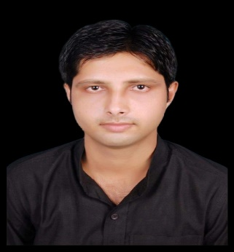

ABHISHEK MISHRA +91-9889141002
Supervisor Guwahati, Assam, INDIA
gisabhishek@live.com
9 Years 7 Month of experience

Career Objective

I wish a challenging position contributing to the success of the Organization by my creative and innovative skills. Being a part of an Industrial Estate that initiates learning process and provides platform for the Continuous Growth.

EMPLOYMENT HISTORY

Working as Supervisor with SETHI TRUST (Guwahati, Assam), (Nov 2024 to till date).

Role and Responsibilities-
- Documentation, Billing.
- Plan and Reports, Team Lead & Supervision work.
Worked as Business Manager (Analyst) with RYCHLE TRANWHEELS PRIVATE LIMITED Powered by SIGVTS Corporation. (Oct 2017 to Oct 2024).

Role and Responsibilities-
- Recruitment management, Human Resource, Team Management
- Documentation, Plan and Reports, Sale and Purchase.
- Team Lead, Monitoring GPS installation work.
- Leadership the team and process together About GPS.

Worked as Project Coordinator (Team Leader) in SAGAR CONSTRUCTIONS,
Gorakhpur, (Aug 2015 to Feb.2017).

Role and Responsibilities-

- Project coordinates, Team Lead and processes running smoothly.
- Documentation, Plan and Reports.
- Maintenance of head count databases, Materials, Equipment’s, Resources, Management and information.
- Provide leadership the team and process together for project implementation.

Worked as Field staff “A” (Junior Scientist) in Remote Sensing Application Center U.P, Lucknow in State Water Sanitation Mission Project, (February 2014 to June 2015).

Role and Responsibilities-

- Project coordinate, Team lead and exceptional ability to work independently as well.
- 15days worked in Pilot Project in Mauranipur Block, Jhansi. (SWSM project).
- Knowledge of Handling GPS, Water Testing, Sanitizing, Field survey.
- Field data collection as well as water quality testing in its project.
- A confident and fast learner with strong communication skills.

Professional Qualification

Years | Qualification/Degree | Board/University | Percentage/ CGPA
2019 | M.A. (Geography) | UPRTOU, Prayagraj | 66%
2012-13 | GIS & Remote Sensing Certificate Course | All India Institute of Local Self Government,  Pune, Maharashtra. | B
2011 | MSc. (IT) | EIILM University | 68%
2009 | B.A. (Geography) | Deen Dayal Upadhyay  Gorakhpur University, Gorakhpur. | 54%

Personal Details -

Date of Birth : 15-07-1992
Father’s Name : Shri D.S. Mishra
Gender : Male
Nationality : Indian
Languages Known : English and Hindi
Hobbies : Planting and caring for Trees, Traveling to new Places, Play Cricket.

I declare that the details above are correct and true to the best of my knowledge.

Sincerely


Abhishek Mishra

