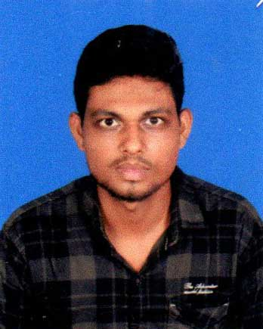
BIO-DATA
NAME : -SALIL KHIRALI
PHONE NO – 8670952155
EMAIL ID-khiralisalil@gmail.com
AADHAAR NO – 8199 0975 0838

PERSONAL INFORMATION
Father Name :- AJIT KUMAR KHIRALI
Mother Name :- ARPITA PATRA KHIRALI
Date of Birth :- 08/01/2002 Sex :- MALE Caste :- SC Nationality :- INDIAN Religion :- HINDU Married Status :- UNMARRIED Languages Known :- BENGALI,ENGLISH,HINDI
PRESENT ADDRESS | PERMANENT ADDRESS
Vill :- BASANTAPUR Post :- RANARANI P.S :- BINPUR Dist :- JHARGRAM Pin No :- 721504 State :- W.B | Vill :- BASANTAPUR Post :- RANARANI P.S :- BINPUR Dist :- JHARGRAM Pin No :- 721504 State :- W.B

Educational Qualification :-
Examination Passed | Name of the Board/University | Year of Passing | Total Marks | Marks  Obtained | % of  Marks
M.P | W.B.B.S.E | 2018 | 700 | 355 | 50.71
H.S | W.B.C.H.S.E | 2020 | 500 | 447 | 89.40
B.A | VIDYASAGAR UNIVERSITY | 2023 | 1900 | 1354 | 71.26

Other Qualification :- IT SMART PLUS WITH DIPLOMA .
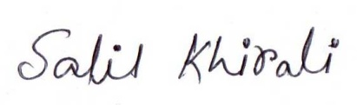
Declaration: I do hereby declare that the above stated information are true best of my knowledge and belief and my candidature likely to be cancelled if any of the particulars submitted are found to be incorrect.

DATE:- 04/11/2024
PLACE: - JHARGRAM SIGNATURE

