BIO-DATA
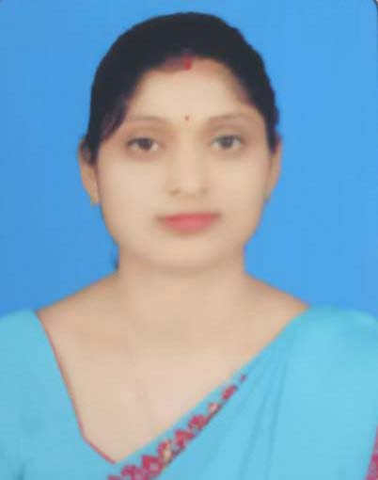

1.Name: Moonsoon Konwar
2.Father’s Name : Narayan Konwar
3.Date of Birth : 02/01/1999
4.Gender: Female
5.Address : Chabua,Dist-Dibrugarh(Assam),Pin-786184
6.Marital Status: Married
7.Caste : OBC
8.Religion : Hindusium
9.Nationality:Indian
10.Languages Known: English,Assamese, Hindi
11.Contact no. : 7636972602
12.E-mail: moonsoonkonwar123@gmail.com
EDUCATION QULIFICATION
Exam passed | Year of  passing | Name of institution | Board | Division | Percentage
H.S.L.C | 2015 | Assam Vidyapith H.S.School | SEBA | second | 41.83%
H.S.S.L.C | 2017 | Assam Vidyapith H.S.School | AHSEC | first | 35%

OTHER QUALIFICATION
- Advanced Diploma in computer Application(ADCA)
- Diploma in Medical Laboratory Technology (DMLT)

DECLARATION
I hereby declare that all the above information is ture to the best of my knowledge.
Date: 07/07/2025 Signature:
